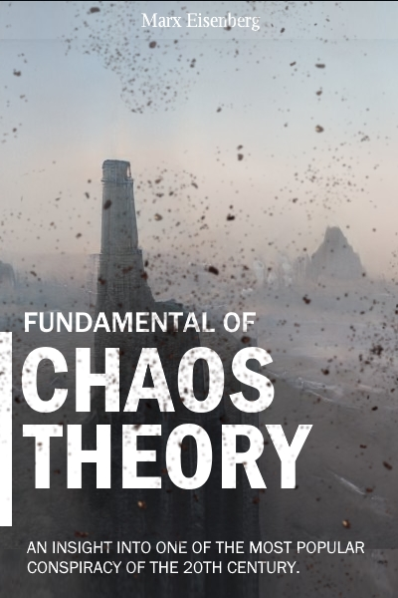

First published year in 2047 by Spiral Enterprises.

Main author: Marx Eisenberg.

**2055 EDITION**

[**ENGLISH VERSION**]

**Author Message**

The Fundamental of Chaos Theory is a modern book of a political manifesto: Chaos Theory dated back from 19th century by a Bunderlifean scholar, **John Von Havenix**.

**Core Message**

Every 20 years, there must be a chaos, a disturbance to the current ruling power to enable a 'shuffle of power'. There will causalities but chaos is needed to be able to investigate the flaws of a nation's system quickly, it is better to have small scale disturbance than a bigger fault found later when country is on mature stage.

Believers of ‘eternal peace’ argued only by establishing a true socialist state where competition is kept to a minimum, society organized into a communal society and every goods belongs to the people can we get peace.

However, in the real world, there’s no such thing as eternal peace. When technology progress is slow, nation leaders will always pursue conquest rather than investing research and development.

# Hypocrite of the Developed Nations

There is no doubt that the noone enjoys working as a labourer working in a factory for 10 hours a day, 6 days a week; developed nations will try every single method to prevent bring themselves into a situation where they have to work hard just like in the 20th century. There is a reason why these countries deindustrialized and their economy turned to services.

Downstreaming the industry to the less developed countries and technology transfer will be slowed down. The so-called capitalism, democracy and freedom-of-speech is great boomerang against capitalist country like United States. Bunderlifean’s **Social-Capitalism** warned when neoliberalism or capitalism went unchecked, deindustrialization will endanger the state’s national interest.

A great danger is if less developed nations get less capital from developed countries to establish industry or gain technology, the power of ideological indocrination will slowly take over the country’s populace.

# Unfeasible Standard

Raising living standard must be stabilize, if the factories or industrial capacity failed to keep up with the demand then inflation will increase. This is obvious, but what’s less obvious is the standardization of acquiring luxury goods or some item for people to get into the ‘Club of Rich People’ or some member of society.

A billion people living in a planet would be fine but a billion people with the standard living of a millionaire? It would take an insane amount of resources and manpower to sustain that standard.

# Division of Society

We see society has been divided into many types: The Otaku culture, the gamer culture, the social-media girls, the investors club, rich people, intellectual culture or many others. This rapid divergence of society is all are just product of capitalism; construct people and categorizes them into a box. These boxes are called ‘user persona’; with easy categorization of people, it would be easy for rulers to control these people. Take the common behaviour of these groups and exploit it.

Maybe the ‘rulers to control these people’ can be a stretch but one thing is certain is that the wildly different group of people meant miscommunication, antipathy and ignorance will increase.

Herding people like sheep and categorization of people is a modern form of caste. Children in a classroom with different economic background will be equal but the people’s occupation and economic condition will infect their behaviour in the long term.

* When I said ‘modern caste’, this is not about between rich people and poor people or civilian vs ruler; modern form of caste is the grouping of people into a box.
* This modern caste is not seen clearly by people today similar how most peasants in medieval age can’t see feudalism until Napoleon started to invaded Europe and spreading liberal ideas.

# Systematisation of